PHEM sub-specialty training in the east

The East of England has had doctor involvement in PHEM for over 40 years and has been home to many major developments over the years, including piloting training posts for the new sub-specialty. We have an approved programme of PHEM sub-specialty training that appointed its first trainee in August 2012 and now hosts the most PHEM trainees in the UK.
Our training programme
We aim to provide a high quality, integrated training programme for trainees using the expertise available in all organisations in the region. Trainees are employed by the Dept of Pre-hospital and Retrieval Medicine at Cambridge University Hospitals (the regional Major Trauma Centre) and hosted by our partner providers –
- Magpas Air Ambulance (based at Alconbury, Cambridgeshire)
- Essex and Herts Air Ambulance (based at North Weald Airfield near Harlow)
with assistance from the East of England Ambulance Service. Trainees will normally rotate between 2 bases, experiencing different ways of operating, different aircraft, and exposure to different areas – from the large eastern coast to the very rural fenland areas to the cities and fast motorways through the region. Organisations operate by land and air, day and night.
Please note that East Anglian Air Ambulance are not part of this recruitment.
Why the East of England programme?
High quality training, investing in trainees - We aim to provide high quality training with experienced organisations supported closely by NHS organisations focused on PHEM. This is about training and developing trainees, and we invest in simulator based training, regional training days, case review days, specialist courses, and joint training with other services. We are proud of a very good trainee pass rate in the national PHEM exams.
National IBTPHEM Course - All trainees will be sent on the National IBTPHEM Induction Course joining trainees and trainers from around the UK in a one week residential course learning about the pre-hospital environment and actually practicing on the training ground on trains, motorways, airplanes and ships.
EoE PHEM Course - After the national course, return to the East of England a local residential course to focus on clinical practice. All trainees in all our organisations attend. Both these courses are fully funded by the charities involved.
Phase 2 course – the Deanery will fund your attending the IBTPHEM Phase 2 residential course looking at the advanced elements of PHEM practice.
Regional Training Days – we have the most PHEM trainees in a region and organise a monthly regional training day covering all aspects of the curriculum. Feedback from this has been exceptional.
Geography – the east of England is a big region with large rural areas with challenging access, large towns and cities and hundreds of miles of coastline. This variation provides challenges to pre-hospital clinical care and variety.
Experienced organisations – led by Addenbrooke’s Hospital in Cambridge, we are proud to have strong, clinically led PHEM organisations involved in our programme. Between them they offer responses by helicopter and rapid response vehicles, day and night. Your Educational Supervisors are very experienced and heavily involved in national PHEM training – organising the National Induction Course, examiners for the NSA1 and 2, leading the IBTPHEM.
In the words of a previous trainee –
“I can honestly say that the PHEM training and Educational Supervision in the East of England is by far the best I've experienced in my career to date. I was trained, supported, nurtured, and respected through my last two years, and I'm quite sad to have to go back to normal "training". This is what training should be like - well planned and delivered, while being adaptable and responsive to feedback.”
Interested?
If you are interested in PHEM training in the East of England, it’s worth getting in touch and finding out more. Observer shifts with organisations involved are often available and a useful way of finding out more. Have a look at our website https://heeoe.hee.nhs.uk/em_phem or get in touch with me. If you would like to speak to one of our current trainees or previous trainees, we can arrange that.
Dr Simon Lewis, Training Programme Director
s.lewis@addenbrookes.nhs.uk
 | PHEM sub-specialty training in the East
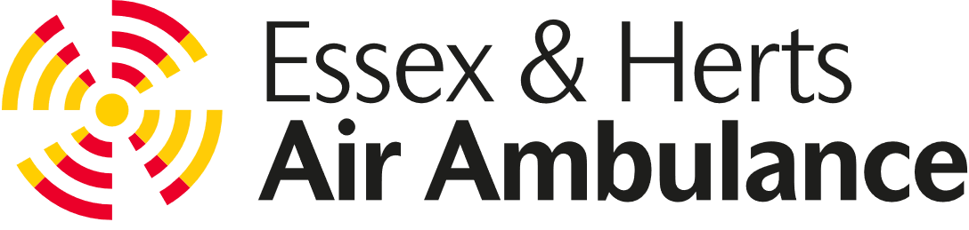 |  | 