Skimpot Road

This car park is 0.6 mile away from the Hospital site (about 12 minutes' walk) and has clearly indicated spaces for L&D staff.

There are two potential routes for getting to the hospital – one along Dunstable Road, the other along the quieter roads of Hayhurst Road, Bampton Road and Stanton Road. Which route you follow will be your choice, but the maps for both routes are attached:

Getting to the hospital:
The Skimpot Road Business Park is 12 minutes from the hospital. There are two potential routes for getting to the hospital – one along Dunstable Road, the other along the quieter roads of Hayhurst Road, Bampton Road and Stanton Road. Which route you follow will be your choice, but the maps for both routes are attached:
Route 1
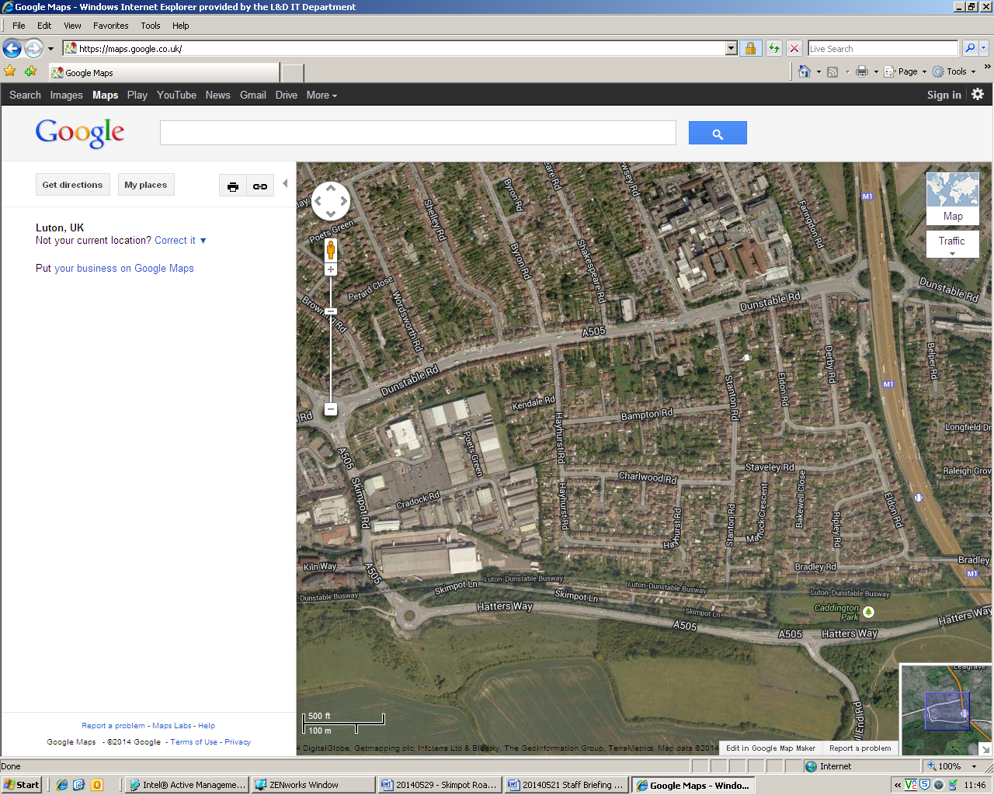 | Route 1 (Red)  - Leave the Business Park and turn right onto Skimpot Road.  - Turn right again at the roundabout and walk along Dunstable Road.  - Keep walking along the south side of Dunstable Road until you reach the Pelican Crossing just after Fendon Road.  - Cross Dunstable Road and enter the hospital site.

Route 2
Route 2 (Blue)
- Follow Cradock Road into the Business Park and follow the alleyway at the east side of the car park.
- At the end of the alleyway, turn left into Hayhurst Road.
- On Hayhurst Road, turn right into Bampton Road
- At the end of Bampton Road, turn left into Stanton Road
- At the end of Bampton Road, turn right onto Dunstable Road – you are now opposite the hospital site.

