
East of England School of Public Health
Supervisor training and accreditation Policy v.6 (Feb 2026)
- National requirements and standards for trainer recognition

  - The GMC trainer recognition framework was introduced in 2016 to ensure high-quality medical education and patient safety by formally recognising trainers, promoting consistent standards in training, and validating educator roles in job planning.

  - The School of Public Health has a responsibility to identify appropriate supervisors, ensure that they are properly trained and demonstrate the full requirements according to specific criteria. The School must maintain an accurate and up-to-date database of accredited supervisors.

The School annually submit a list of all accredited supervisors on the GMC register to the GMC (via the Deanery Faculty development team) and under the Medical Act, the GMC publishes a note on the medical register entry: “This doctor is a trainer recognised by the GMC”. (In March 2025, the GMC advised that there will no longer be an expiry date on a trainer’s accreditation record, meaning they will be listed as a named supervisor on GMC Connect until the Deanery or the trainer advise the GMC otherwise.)
UKPHR registrants are able to login to the UKPHR portal and complete an application to confirm their status as an educational supervisor.

  - Supervisor competency domains:
The GMC recognises seven domains of competence, from the Academy of Medical Educators (AoME) “Professional Standards for medical, dental and veterinary educators” (2014):
1. Ensuring safe and effective patient care through training
2. Establishing and maintaining an environment for learning
3. Teaching and facilitating learning
4. Enhancing learning through assessment
5. Supporting and monitoring educational progress
6. Guiding personal and professional development
7. Continuing professional development as an educator.

Educational Supervisors (ESs)must demonstrate evidence across all 7 domains; Clinical Supervisors (CSs) must demonstrate evidence in five domains (1-4 and 7), although they should be aware of domains 5 and 6. (AoME has subsequently updated their professional standards, but the original 7 standards are still used for the GMC Recognition process.)

  - The Faculty of Public Health (FPH) describes minimum standards for Public Health Consultants to be placed and maintained on the GMC register and UKPHR as supervisors. The FPH “expect that all seven (domains) will be covered over a three-year period (minimum two per year) together with Equality and Diversity Training”,. The FPH specify that “Educational and Named Clinical Supervisors will produce plans in their PDPs to maintain competence and strive2024 to achieve excellence in accord with FPH guidance on standards. Any actions to maintain minimum standards or to achieve excellence should be suitably documented”.

- Supervision in the EoE PH training programme:

  - Educational Supervisors:
Longitudinal supervision is provided throughout Public Health training by a named, accredited Educational Supervisor (ES). “The ES is selected and appropriately trained to be responsible for the overall supervision and management of a trainee’s trajectory of learning and educational progress during a placement or series of placements”.
In the EoE Public Health Training Programme (in comparison to some other programmes), the ES role is completely separate from the Clinical Supervisor, covering the whole training period and not linked to location. The ES oversees the educational progress of the trainee and helps the trainee to plan their training and achieve agreed learning outcomes. He or she is responsible for: the educational agreement; signing off all learning outcomes; and for drawing evidence from a range of sources including clinical, activity and academic supervisors to form a summative judgement in the Educational Supervisor’s report for the ARCP (see Appendix 1: Roles and responsibilities of Supervisors”).

  - Clinical Supervisors: A named Clinical Supervisor (CS) is a trainer who is responsible for overseeing a specified trainee’s service work throughout a placement in a public health environment and is appropriately trained to do so. The CS oversees the service work of the trainee during one attachment and provides constructive feedback during that placement. They will provide information to the Educational Supervisor for their report to the ARCP panel, and usually sign off most activity summary sheets (see Appendix 1).

  - Eligibility:
All Educational and Clinical supervisors must meet the eligibility criteria for accreditation:
  - Be on a relevant Specialist Register (GMC, GDC or UKPHR);
  - Have been in a Consultant post for 12 months before commencing clinical supervision (in line with EoE GP training requirements) ;
  - Have their supervisor role described in their job plan (or equivalent) with protected time for supervision (NACT has recommended approximately 0.25 PA per registrar should be identified for face: face meetings, ARCP requirements, administrative and CPD time );
  - Be annually appraised in their educator role across the five/seven AoME/GMC standards. In line with the GMC requirement that appraisal includes the whole scope of practice, evidence of educational activities and CPD should be included in the process as well as feedback on performance as an educator and inclusion of supervisees in a multisource feedback exercise;
  - Be equality and diversity trained every 3 years.

  - All accredited Clinical Supervisors can be named Clinical Supervisor for a maximum of two Public Health registrars plus one GP or FY trainee at a time. This is the case even if any of the trainees work LTFT, based on the assumption that each individual will require similar supervision time commitment regardless of how many hours they work.

  - ES contract: ESs are contracted for their role with quarterly retrospective payments made to individuals or their employer. If an ES is off sick or unable to fulfil their ES role for whatever reason, they should inform the School on the first day of absence in the same way as any other employer. Their payments will cease after 4 weeks in order for alternative supervision arrangements to be made and paid for. A monthly fee is awarded per registrar supervised, irrespective of whether the registrar is on parental leave, off sick or out of programme.

- NHS E WTE East of England (EoE) Deanery Faculty Development and new requirements

  - The NHSE WTE, EoE faculty development (FD) team sets core requirements for EoE supervisors in order to be accredited and offers career guidance and career progression for educators at different tiers (see Figure 1) in their educator career.
Figure 1.
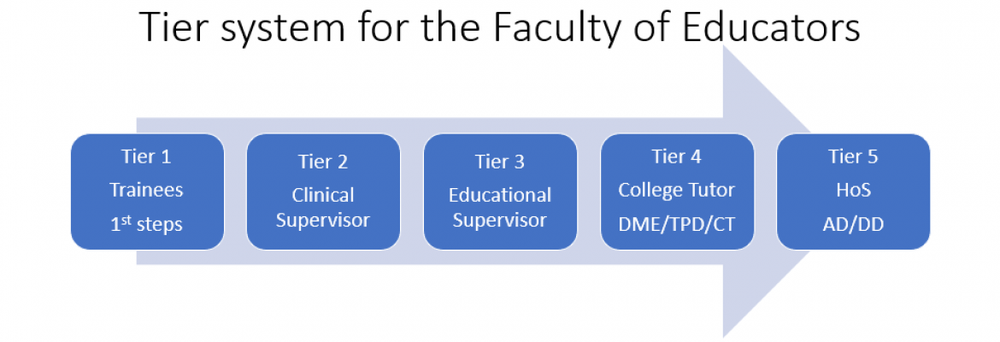
  - During the COVID-19 pandemic a suite of online materials were developed to offer FD sessions to accredit supervisor in Tiers 2 and 3, supplemented by attendance at an (online) course delivered by a Higher Institute of Education.

  - In 2021, the School of Public Health developed a ‘Padlet’ online web resource to guide PH supervisors through the various Deanery requirements of eLfH and videos. This also included 3 bespoke online webinars to cover the core educational theory elements of the HIE course, tailored to PH training. The materials were grouped into 4 core themes for ease of navigation (see Figure 2 below) and 5 learning outcomes were created for each theme to make explicit the knowledge and skills required by ESs & CSs.

  - New requirements were agreed in 2025 for supervisors in secondary care and a new GP Educator training pathway (and handbook) was also developed. Key changes include:
- Retirement of the eLfH modules & HEE online videos;
- Development of 3 online (asynchronous) modules on the Deanery Postgraduate Virtual Learning Platform (PGVLE):
- A move to face:face Cs workshops instead of online ‘hub’ days;
- Requirements for attendance at the face:face workshops and an ‘honour’ system of signing a form to attest completion of asynchronous materials, instead of the need to provide reflective notes or specific evidence.

Figure 2: Public Health CS Training Pathway 2021:
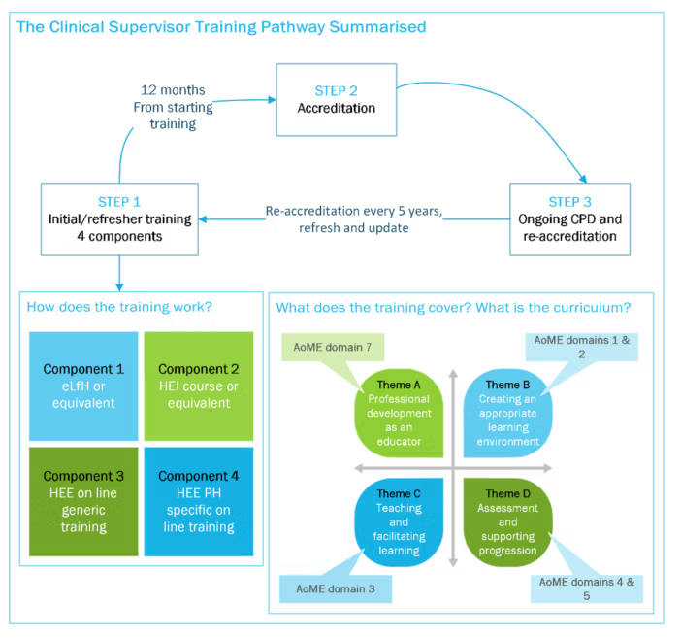

  - In response to the Deanery change in requirements, the PH Training Programme has updated the CS training Padlet to reflect this. The 5/7 domains remain mapped to 4 core training themes (see Table 1) and there have been no changes to the 20 key learning outcomes for PH CSs (see Appendix 2). The core content from webinars, eLfH modules and videos is now encompassed in 4 x 4 hour face:face CS workshops delivered annually across 2 days. These provide core training for new supervisors and also useful refresher and CPD for supervisors wishing to become re-accredited.

  - Table 1: Public Health CS Training Pathway Themes 2026, mapped to AoME/GMC themes:
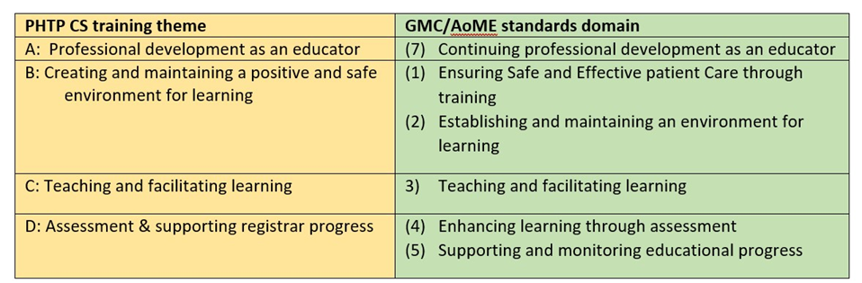

- Public Health Clinical Supervisor Training

  - The updated training materials for Public Health Clinical Supervisors are detailed in Appendix 2. Prospective supervisors will be required to review and reflect on various online resources listed in the Padlet, which include:
- Core documents from the FPH (e.g. Training curriculum, e-portfolio guide);
- Training forms (e.g. activity summary sheet (ASS); learning agreement forms; workplace-based assessment (WPBA) forms;
- EoE PH TP policies and guidance (e.g. core responsibilities for ES & CSs; induction checklists, supervision meeting templates, Es & CS report templates; quality framework for placements);
- Lead employer policies and guidance;
- Some key educational resources e.g. eLfH Supervision e-module; reflective practice guidance for supervisors; principles of giving feedback; videos on core topics including reflective practice.

  - They will also be required to attend 4 face:face half day workshops (held across 2 days) (see Table 2) which will cover core content outlined in the Deanery FD guide for Directors of Medical Education in secondary care plus additional material deemed pertinent and useful for PH supervision and training
“Trainer recognition is not (intended as) a ‘tick-box’ exercise. Beyond meeting the minimum standards, trainers are expected to develop their skills and competence….supported by the processes involved in trainer recognition.”

  - Educational supervisors will also be required to review the ES theme of the Padlet and attend an ES training day in March, which also serves as a useful refresher and peer support for current accredited ESs prior to the ARCP panel in April/May. This ES training will cover:
- ES roles, responsibilities (including HR line management e.g. expenses & leave) & learning outcomes;
- Supporting trainees with difficulties;
- Assessment & signing off learning outcomes;
- ARCP & the ES report;
- Supporting KA10, MSF and leadership development;
- Careers advice & coaching techniques.

Table 2: CS workshops – outline
Workshop title | CS LOs addressed | Indicative content (Deanery content highlighted in italics)
1a – Roles & Responsibilities of a CS | A.1. …. identify opportunities to develop further skills and knowledge as an educator.  A.4. Understand the responsibilities for clinical supervision of registrars.  A.5. Devise and implement strategies to seek feedback and use reflection to improve as a supervisor.  B.2. Create a positive and effective environment in the workplace which encourages diversity and ensures equality of opportunity for registrars. | - Roles & responsibilities of a Clinical Supervisor  - Key documents and principles of supervision’  - Creating a safe learning environment  - Psychological safety  - The importance of induction  - EDI: Inclusion & Differential attainment
1b: Establishing an effective supervisory relationship & supporting Trainees in difficulty | B.1. Develop an effective relationship for learning e.g. maintaining the confidence of registrars, being approachable, having protected time for supervision.  B.4. …be aware of processes for escalating any issues or concerns in relation to registrar training, progress, conduct or safety (including recommending a Professional SW referral where needed).  B.5. Be able to identify warning signs of a registrar in difficulty, and how to record and escalate any concerns. | - Establishing an effective relationship  - Balancing performance & development  - Motivation and learning styles  - The challenges and barriers of supervising trainees with difficulties  - Understanding causes, identify potential signs of difficulty  - Key actions and approaches for diagnosing difficulties
2a: Teaching & learning theory & skills | C.1. Encourage and support a registrar to engage in meaningful reflective practice  C.2. Use a range of tools to identify learning needs in self and in registrars; and translate a learning agreement into action plans in the workplace.  C.3. Hold an effective developmental conversation with a registrar, including the use of questioning techniques to promote self-directed learning.  C.4. Identify and suggest areas of (multi-disciplinary) work that will develop (and stretch) individual registrars' skills, while contributing to the goals of the host organisation.  C.5. Demonstrate a range of approaches to teaching on a one to one and small group basis and identify opportunities for using simulation and other novel approaches in supervision. | - Techniques for encouraging deeper reflection & learning  - Core educational theories and models  - Teaching strategies to enhance learning and supervision
2b: Assessment, WPBAs & effective feedback | D.3. Understand the principles of workplace-based assessment and use WPBA tools effectively with registrars.  D.4. Undertake regular trainee observation and construct appropriate feedback in line with Programme requirements.  D.2. Communicate effective feedback to the registrar, including in difficult situations.  D.5 Communicate useful feedback to the registrars' educational supervisor on progress, strengths, weaknesses and any areas of concern, and describe the key features of a good supervisors’ report. | - Principles of summative & formative assessment  - Using work-placed based assessments – CBDs & DoPs  - Principles of effective feedback  - Utilising different feedback models and techniques

- Supervisor accreditation

  - Applying for accreditation: To apply for accreditation, applicants must complete the supervisor accreditation form (see Appendices 3&4) which they sign to attest to their: eligibility, attendance at training (also verified by the PH Training Programme) and review of, and reflection on, the Padlet materials. In contrast to pre-2026 requirements, applicants are only asked to submit their E&D certificate, no further evidence or reflections are required to be submitted to the training programme.

  - Approval and feedback: All applications for supervisor accreditation will be reviewed within one month of receipt and approved or rejected by the School of Public Health TPD for Faculty Development. Applicants are also invited in the application form to identify professional development goals and to note any learning needs so this can be accommodated and addressed in the Faculty Development PDDs and online resources.

  - Clinical supervision before accreditation: In line with the Deanery Faculty Development policy for Consultants in a secondary care setting, Consultants in Public Health who are not yet accredited CSs can be a named CS for a PH registrar and start to supervise once they have commenced the training. The Deanery expects those who have started to supervise and commenced the training pathway to complete the required training and accreditation application within 12 months. If this is not completed, supervision must be suspended.

  - Educational supervision before accreditation: Educational Supervisors must be accredited and approved before becoming a named Educational Supervisor. Applicants are expected to have a minimum of twelve months experience as a CS before applying to be an ES. Accreditation as an Educational Supervisor includes both ES & CS accreditation (as the ES training and experience required includes, and exceeds, that required to be a CS) and all new ESs will also have a TPD meeting/briefing prior to being offered the role.

  - Transferring accreditation: Consultants who have been accredited as an Educational or Clinical Supervisor within the last 3 years in a different School or region may submit their previous application paperwork for recognition in the EoE, and be approved for a further 12 months. During this 12 months, they are expected to attend the 4 CS training workshops (2 days) and submit the accreditation form.

  - Data collection and storage: Once a supervisor has been approved, a core dataset will be held on the EoE PH TP Supervisor database (saved securely on the programme SharePoint, accessed only by PH TP faculty), including the following details:
- Name (full name if registered with the GMC) & GMC/UKPHR number;
- Place of work (training location & associated GMC approval codes) & contact email;
- Date of last E&D training;
- Date of accreditation (past and present);
- Attendance and participation at training workshops, Professional Development days, STC, ARCP panels and mock exams.

- Ongoing continuous professional development
  - Professional Development days (PDDs): All Supervisors will be invited to attend the School of Public Health Professional Development days, held at least annually usually in May, as well as the two annual CS training days and ES training day. Supervisors will be added to an email distribution list and will also be asked to engage with any communications from the Lead for Faculty Development or other members of the School team, providing updates on training and opportunities for professional development.

  - Attendance at STC, ARCP panels and support for regional training: In addition, Educational Supervisors are expected to attend at least 4 meetings of the Specialty Training Committee and attend an ARCP panel once every 3 years.
Educational supervisors are expected - and Clinical Supervisors encouraged - to contribute to regional training where possible e.g. as an examiner for the mock OSPHE in Autumn; provide written feedback as a written examiner for the DFPH mock exam in January. Offers to provide regional teaching and share expertise and experience on a variety of topics are always welcome and often sought by PHREE.

  - Regional Professional development opportunities: The Deanery Faculty Development team offer a number of face-to-face targeted masterclasses and a bi-annual educator symposium (one face:face, one virtual) which supervisors are encouraged to sign up for (https://heeoe.hee.nhs.uk/faculty-educators/development-and-networking-events).

  - Appraisal and revalidation: The training and accreditation process is designed to align with revalidation and appraisal paperwork, which requires Consultants involved in training to demonstrate appropriate knowledge, skills and attitudes in each of the 7 domains in their annual appraisal. The mapping of the framework and application form, and wider Deanery faculty development offerings, should help Supervisors populate each domain of their appraisal paperwork. Reflective notes on supervisor training and PDDs can be used for FPH CPD and for evidence for appraisal / revalidation.

- Renewal of accreditation after 3 years

  - For ongoing recognition and re-accreditation after 3 years, Educational and Clinical Supervisors must complete the accreditation renewal form (see Appendix 4).

  - All supervisors are expected to keep their CPD up to date throughout their 3 years of accreditation. After 3 years, to request renewal CSs and ESs will be expected to have:
- Attended one CPD event annually and a minimum of 3 days CPD over the past 3 years (CS or ES workshops as refreshers, Professional Development days, NHSE WTE masterclasses, symposium or other accredited medical education CPD);
- Completed Equality & Diversity training a minimum of every 3 years;
- Included their educator role in their appraisal and included evidence of feedback on their educator role;
- Participated in their training location quality self-assessment exercise.

  - Educational supervisors will also be expected to continue to engage with the programme regularly and:
- have attended the annual ES training day in March at least once every 2 years;
- attended ARCP panel once in the last 3 years;
- attended STC a minimum of 4 meetings per year.

  - If a supervisor does not wish to comply with these requirements and does not seek to be re-accredited, the Training Programme will remove the supervisor from the database of accredited supervisors, and inform the GMC, via the Deanery FD team, that they no longer have trainer recognition status.

Document title: EoE Public Health Training Programme: Supervisor accreditation and training Policy
Version: 6
Author: Kirsteen Watson (TPD)
Version 5 | July 2021. | Amended with new forms from training package
Version 4 | Sept 2020 | Circulated to STC and reviewed at STC meeting
Version 3 |  | Significant amendments in light of HEE developments regarding online supervisors training – development of a new pathway and training package.
Version 2 | July 2020 | Circulated to STC for comments
Version 1 |  | Reviewed and amended by SMT: Jan Yates, Anne Swift, Sara Godward, Hannah Gunn
Approved by: STC
Approval date: 11th March 2026 (TBC)
Review date: 11th March 2028

Appendix 1:
EoE Public Health Training Programme - Roles and responsibilities of Educational Supervisors
Ensure a safe and positive learning environment:
- Oversee the education of a trainee across placements;
- Keep knowledge of the FPH curriculum requirements and e-portfolio up to date, including expected levels of competence;
- Meet with registrar regularly every 4-6 weeks, and at the beginning and end of every placement to review and monitor progress;
- Ensure registrars have received a thorough induction and check whether their learning environment is safe, positive and supportive;
- Ensure registrars have a CS available and supervision is appropriate for their needs.
Support assessment of learning needs and work programme:
- Identify learning needs and opportunities required to enable the registrar to meet the curriculum;
- Agree a Learning Agreement every 6 months, or for every new placement (and if relevant, LTFT training plan);
- Ensure work allocated in training locations is suitable for stage of training and learning needs;
- Ensure the registrar participates in 360 appraisal and support reflection on findings;
- Advise on achievement of KA10 competencies and opportunity for KA10 panel.
Review educational progress and support professional development
- Review portfolio of work, including outcomes of workplace-based assessments and conduct case-based discussions where relevant;
- Review educational progress against the curriculum and learning agreement and provide guidance as needed at regular intervals;
- Review and sign off learning outcomes, to confirm expected level of competence;
- Review and provide written feedback in Activity Summary sheets for work conducted outside of regular placements e.g. publications, teaching, exams;
- Provide specific, constructive and timely feedback on progress and reflection;
- Encourage reflective practice to consolidate and expand learning;
- Complete a structured Educational Supervisor report that discriminates between strengths and any areas for improvement.

Provide line management functions, including pastoral support:
- Develop a supportive relationship and provide signposting to support for health and wellbeing;
- Facilitate access to careers advice;
- Be able to recognise signs of a trainee in difficulty; identify and escalate any issues or concerns regarding registrar performance, progress or welfare to the TPD and & if required, prepare remediation support plan with Training Programme Director.
- Review "Form R (Part B)" (for appraisal) and report any Serious Incidents involving registrars;
- Consider and sign-off Study Leave requests; monitor annual leave days taken
- Review and sign-off sickness absence form and conduct return-to-work interviews;
- Review and sign-off expenses claims.

EoE Public Health Training Programme - Roles and responsibilities of Clinical Supervisors
- Oversee the education of a trainee in a specific placement;
- Keep knowledge of the FPH curriculum requirements and e-portfolio up to date, including expected levels of competence;
- Provide protected time for supervision and ensure registrar has access to support when required (e.g. access to Consultant team if you are unavailable);
- Plan induction with "Training Location lead" and ensure the learning environment is safe, positive and supportive;
- Identify learning needs and opportunities required to enable the registrar to meet the curriculum;
- Agree a work programme and projects suitable for stage of training and targeted to achieve the Learning Agreement/LOs, including areas of responsibility as appropriate;
- Review progress and provide guidance as needed at regular intervals;
- Provide specific, constructive and timely feedback on performance and reflection;
- Encourage reflective practice to consolidate and expand learning;
- Review and provide written feedback in Activity Summary sheets to evidence work contributing to specific learning outcomes has been achieved;
- Organise/contribute to workplace-based assessments;
- Write a Clinical Supervisor report to inform the Educational Supervisor report for ARCP;
- Sign Annual Leave records and notify the ES and TPD of any unauthorised absence;
- Identify and escalate any issues or concerns regarding registrar performance, progress or welfare to the ES and TPD.
- Encourage access to and participation in regional training and study leave

Appendix 2: Learning objectives, key training requirements and materials for PH CSs mapped to 4 training themes & 2 Face:face workshops

Learning objectives & key topics for Clinical Supervisor training and accreditation

Theme | Key topics in online training materials  (click link to jump in this document to training topic) | Key learning objectives  As a Clinical Supervisor, you should be able to: | Core resources
- Professional development as an educator | A.1 GMC & FPH requirements & EoE PHTP Supervisor policy: and CPD opportunities. | A.1. Participate in the EoE PH supervisor development programme; participate in CPD in line with GMC / FPH / UKPHR requirements; and identify opportunities to develop further skills and knowledge as an educator. | EoE Public Health Training programme (EoE PH TP) policy - Supervisor accreditation & training pathway policy
- Professional development as an educator | A.2. Guide to the FPH curriculum & the e-portfolio | A.2. Demonstrate up-to-date knowledge, and support delivery of, the FPH curriculum; use the learning portfolio (including e-portfolio) and understand the East of England PH Programme structure and delivery. | FPH Public Health curriculum  FPH Training supervisor/e-portfolio guidance  EoE PH TP – website & policies
- Professional development as an educator | A.3 EoE PHTP overview & structure | A.3. Understand the role of the clinical supervisor in educational governance and interactions and communication with other core members of the training team e.g. TPD, FD lead, Educational supervisors. | EoE PH TP – Specialty Training management structure
- Professional development as an educator | A.4. Clinical Supervision – what it entails | A.4. Understand the responsibilities for clinical supervision of registrars. | EoE PH TP - Roles & responsibilities of PH supervisors  CS workshop 1a – Roles & Responsibilities of a CS
- Professional development as an educator | A.5 Trainee feedback & evaluating your skills | A.5. Devise and implement strategies to seek feedback and use reflection to improve as a supervisor. | Padlet – Development & feedback
- Creating and maintaining a positive and safe environment for learning | B.1. Effective supervisory relationships | B.1. Develop an effective relationship for learning e.g. maintaining the confidence of registrars, being approachable, having protected time for supervision. | eLfH module – Supervision  CS workshop 1b – Establishing an effective supervisory relationship & supporting Trainees in difficulty  EoE PH TP – CS meeting checklist/template
 | B.2. Equality & diversity | B.2. Create a positive and effective environment in the workplace which encourages diversity and ensures equality of opportunity for registrars. | EoE PH TP – Quality Framework & Programme policies  Equality & Diversity training
 | B.3. Effective induction | B.3. Describe the important features of induction to the workplace and critically evaluate and improve existing induction programmes. | EoE PH TP - Induction checklist
 | B.4. EoE PHTP, HEE & Lead Employer Policies and procedures & the  Professional Support and Wellbeing Unit | B.4. Apply HEE and training programme policies; and be aware of processes for escalating any issues or concerns in relation to registrar training, progress, conduct or safety (including recommending a Professional SW referral where needed). | EoE PH TP - Trainer guide to HR & line management roles  HEE Video - Introduction to PSW
 | B.5. Supporting trainees in difficulty | B.5. Be able to identify warning signs of a registrar in difficulty, and how to record and escalate any concerns. | CS workshop 1b – Establishing an effective supervisory relationship & supporting Trainees in difficulty  NHSE Policy: ‘Trainee in Difficulty’ and summary of roles handout  Additional resources
- Teaching and facilitating learning | C.1. Using and encouraging reflective practice | C.1. Encourage and support a registrar to engage in meaningful reflective practice | CS workshop 2a – Teaching & learning theory & skills  EoE PH TP – Placements & training locations webpage  EoE PH TP – Regional training programme guide  FPH Learning agreement template  FPH Activity summary sheet template  Additional resources
- Teaching and facilitating learning | C.2. Assessing learning needs & developing a learning agreement | C.2. Use a range of tools to identify learning needs in self and in registrars; and translate a learning agreement into action plans in the workplace.
- Teaching and facilitating learning | C.3. Developmental conversations | C.3. Hold an effective developmental conversation with a registrar, including the use of questioning techniques to promote self-directed learning.
- Teaching and facilitating learning | C.4. Principles of workplace-based learning | C.4. Identify and suggest areas of (multi-disciplinary) work that will develop (and stretch) individual registrars' skills, while contributing to the goals of the host organisation.
- Teaching and facilitating learning | C.5. Models of teaching and learning | C.5. Demonstrate a range of approaches to teaching on a one to one and small group basis and identify opportunities for using simulation and other novel approaches in supervision.
- Assessment & supporting registrar progress | D.1. Supporting exam preparation and performance | D.1. Understand the requirements of, and required preparation for, MFPH exams and support the registrar in working towards these alongside service commitments. | FPH Exams guide
- Assessment & supporting registrar progress | D.2. Workplace-based assessments | D.3. Understand the principles of workplace-based assessment and use WPBA tools effectively with registrars. | CS workshop 2b – Assessment & using WPBAs  FPH Public Health curriculum
- Assessment & supporting registrar progress | D.3. Expectations and judging levels of competence | D.4. Undertake regular trainee observation and construct appropriate feedback in line with Programme requirements.
- Assessment & supporting registrar progress | D.4. Effective feedback | D.2. Communicate effective feedback to the registrar, including in difficult situations. | CS workshop 2c – Effective feedback  ARCP information  EoE PH TP – CS Report template
- Assessment & supporting registrar progress | D.5. Useful supervisor reports | D.5 Communicate useful feedback to the registrars' educational supervisor on progress, strengths, weaknesses and any areas of concern, and describe the key features of a good supervisors’ report.

GMC Recognition and Approval of Trainers. Available at: https://www.gmc-uk.org/education/how-we-qualityassure/medical-schools/recognition-and-approval-of-trainers.
https://medicaleducators.org/write/mediamanager/aome_professional_standards_2014.pdf
“Professional Standards for medical, dental and veterinary educators, 4th Ed” (2021): https://medicaleducators.org/write/MediaManager/Documents/AoME_Professional_Standards_4th_edition_1.0_(web_full_single_page_spreads).pdf
“Appendix 1- FPH Public Health Trainer definitions document. Criteria and Standards for Educational Supervisors.” Available at: https://www.fph.org.uk/media/1116/appendix-1-fph-public-health-trainer-definitions.doc
“DRAFT STANDARDS Supporting Information for Educational and Named Clinical Supervisor roles”- Appendix 2.” Available at: https://www.fph.org.uk/media/1114/appendix-2-supporting-information.doc
“Appendix 1- FPH Public Health Trainer definitions document. Criteria and Standards for Educational Supervisors.” Available at: https://www.fph.org.uk/media/1116/appendix-1-fph-public-health-trainer-definitions.doc
“The Gold Guide: A Reference Guide for Postgraduate Foundation and Specialty Training in the UK” 10th Edn. Aug 2024. Available at: https://www.copmed.org.uk/publications/gold-guide/gold-guide-10th-edition
Ibid.
https://heeoe.hee.nhs.uk/general_practice/tier-3-gp-trainer
https://www.fph.org.uk/media/eqnjys3c/good-public-health-practice-framework-october-2024.pdf
“Appendix 1- FPH Public Health Trainer definitions document. Criteria and Standards for Educational Supervisors.” Available at: https://www.fph.org.uk/media/1116/appendix-1-fph-public-health-trainer-definitions.doc
https://heeoe.hee.nhs.uk/faculty-educators/tiered-approach
https://heeoe.hee.nhs.uk/faculty-educators/tiered-approach/tier-2-clinical-supervisor-and-tier-3-educational-supervisor
https://www.gmc-uk.org/cdn/documents/approving-trainers-implementation-plan-aug-12-v2_pdf-66144233.pdf

