School of General Practice
Professor John Howard, Head of School of GP & Dean of Postgraduate GP Education


CPC1, Capital Park
Fulbourn, Cambridge CB21 5XE

www.eoedeanery.nhs.uk

ARCP Training Pack 2012
East of England Postgraduate GP School

Contents

ARCP process 3

Scan checklist 4
Check last ARCP report 4
Posts 5
Trainee Self-ratings 5
Educational Supervisor Ratings 6
Curriculum coverage 6
Skills Log (DOPS) 7
Naturally Occurring Evidence 8
Evidence (Assessments) 9
Educators Notes 10
PDP 10
Learning Log 11
Progress to Certification 12
Special Cases 13
Appendix A: word pictures for assessing quality in eportfolio 14
Appendix B: Competency word pictures 15
Appendix C: MRCGP Blueprint 15
Appendix D: Workplace based assessments and competences 16

ARCP Process
Every year, every GP trainee, whether they are actively training or out of programme, must have a review of their progress, an Annual Review of Competence Progression (ARCP). This consists of two parts: a review by their educational supervisor and/or their Training Programme Director, followed by a review and decision by the ARCP Panel.
The ESR is not summative. The function of these reviews is to summarise the evidence and, if it is clear whether progress is satisfactory or not, to make a recommendation to the panel.
The review by the ARCP panel is the summative part of workplace based assessment.

Types of ARCP
These types address the issues raised when trainees either take time out of programme, or work part-time (LTFTT).
- Calendar Panels are held on the anniversary of the trainee’s start date – usually in June for the period ending 31 July.
  - Out of Programme (OOP) Panels are calendar panels, but when the trainee is out of training for sickness, maternity leave, or career breaks.
- Transition Panels are held when a trainee is progressing from ST1 to ST2, ST2, to ST3, when that transition does not coincide with the calendar anniversary of their start date. These are usually triggered when a trainee has had time out for sickness, maternity leave etc.

ARCP Panel Process
Panels consist of the following people:
- GP Dean/ Deputy GP Dean/ Associate GP Dean – any of these can be the Chair
- Training Programme Director
- Educational Supervisor
- Lay Member
- RCGP External Assessor (usually for June and December panels only)
There is a three-stage process for panels.
First stage: The admin team fills in the ARCP checklist fields for numerical data (for example number of COTs, log pages).
Here is one example already completed in this way – note that some areas remain unfilled as these must be completed by the screener/ panel member.
Second stage: Trainees’ eportfolios are examined by a ‘screener’ with the aim of recommending an outcome to the formal panel.
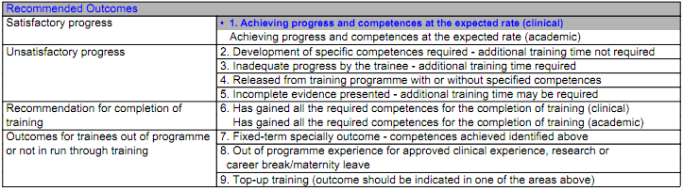
(Outcomes 7 & 9 apply to hospital specialties only)
Third stage: Panels will review all those eportfolios without a satisfactory outcome and 10% of those with a satisfactory outcome. The panel chair will sign off all ARCP decisions.
HOW TO COMPLETE SECOND STAGE (Screening)
We accept that what we are about to suggest does not follow the checklist order exactly, but in our experience represents the most efficient way of doing it.
- Scan the checklist. The admin team will have noted numerical data, and any special circumstances you may need to take into account.
- Check last ARCP report. You find this under Progress to certification in the left hand menu.
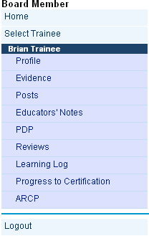
ST1 may not have one. If there were outstanding items leading to an unsatisfactory outcome and recommendation, then you will need to check whether these have been addressed.

- Check the posts:
Open Reviews and click on the most recent ESR which should match the end of the current period. (NB: This is NOT the date the ESR took place.) Under the details of the trainee and supervisor you will see a box containing all their posts to date, and in most cases the future posts as well. There are some rules which have to be met:
ST3 must have completed 36 months FTE (full time equivalent) training to be eligible for outcome 6. This will have been checked by the admin team and the certification unit.
ST3 who have spent less than 18 months in general practice need a special statement confirming that despite this they have achieved the competences required for an outcome 6. This rare circumstance will usually have been picked up by the admin team and entered on the checklist. If not, please do so yourself.
The RCGP always queries any post of less than 3 months duration. This can occur because of sick leave, maternity leave, etc. Again, this should have been picked up by the admin team in advance and recorded on the checklist. However, you will need to check that there is sufficient evidence of learning in the specialty concerned. This is especially important for ST3 trainees. Please note your findings on the checklist if you discover this. We suggest adding the following statement:
‘There is sufficient evidence to demonstrate that appropriate learning has taken place despite the short duration of the *….* post’
If you have any other queries about duration of posts please ask for help on the day.
OOP ARCPs: You should not see any of these, as they do not need to be screened.
Calendar ARCPs for LTFT (Less Than Full Time Training) trainees will have evidence collected over less than a year’s full time equivalent training.
- Trainee self-ratings: Read the trainee self-ratings (under the posts on the same page). Make a comment on their quality in the checklist in the notes box. The college are looking for reflection and referenced evidence.

Try to make your comments constructive as the checklist is emailed out to trainer and trainee after the panel

- Educational supervisor ratings: This is under the heading: Competences: Educational Supervisor Feedback and is immediately below the trainee self-ratings. Check the actual ratings (all should be competent for ST3 final ARCP) looking for below expectations, or any NFD (needs further development) in ST3 final ARCP. You will need to rate and give feedback to the ES on the quality of their comments. You will find boxes for these on the checklist. The word pictures which enable you to judge the rating are at the bottom of the checklist page. (also inserted below)
It is good practice for the evidence cited to be specific, dated, and accompanied by a narrative interpretation of the evidence, outlining what the evidence is, why it is significant, and the next steps. Feedback to the trainee is essential to inform their development, and therefore ideas or recommendations for future development (‘Actions’) should be included in all ESRs, for all trainees, including those at the end of training and those performing at a level above expectation.
For an excellent ES rating your feedback may be as simple as ‘evidence based, referenced, formative feedback provided’
The college standard is for referenced evidence, narrative and formative feedback.
- Curriculum coverage: click on the blue link to page 2 of the review to see this. Use your own judgment taking into account the posts the trainee has done to date. If you are uncertain please ask on the day.

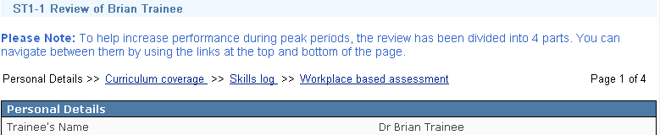
Look at the numbers, and comment on any weak areas. It is useful to look at the ES comments too.
Tip: Trainees should have evidence illustrating coverage of the whole curriculum by the end of training, but poor coverage should have been picked up long before this stage.

- Skills log (DOPS): Click on the blue link at top or bottom of the curriculum coverage to get to page 3 of the review. 

There are two columns of blue figures in the centre of the table. The right hand figure tells you how many satisfactory assessments have been done for each DOPS.
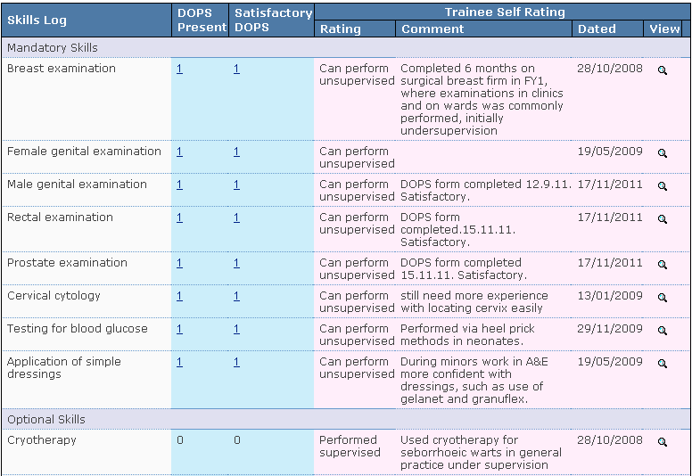
Check one or two to make sure that they have been assessed by a senior clinician. At ST3 final ARCP all the mandatory 8 should have been assessed as satisfactory.

- Naturally Occurring Evidence: click on the Workplace based assessment link at top or bottom for page 4 of review.
The first box is the numbers of assessments done in the last period, which is only 6 months, so ignore this for now. You will be checking a year’s worth of assessments later.
The next box shows all the competences linked to log entries (the column on the left) and assessments (the column on the right). At St3 final there should be no zeros. If links are very sparse or absent for ST1 and ST2 then you could feed this back to the ES in the box you used for feedback on their ratings. On this page you can also rate the ES comments on the PDP and the summary, and give any feedback on these as well if you think it appropriate.

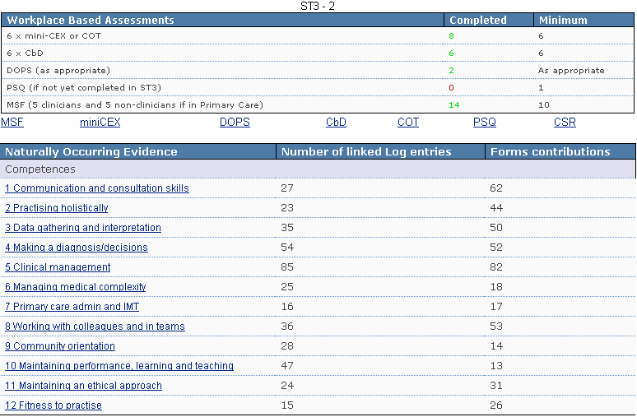
You have now finished checking the ESR itself.
- Evidence: The next thing to check is the assessments – click on the blue Evidence link in the left hand menu:
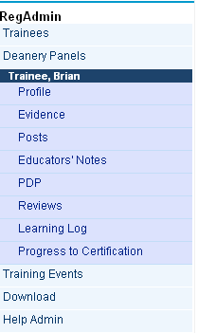
First you will need to set the ‘Review Number’ to ‘All Reviews’ with the Review set to the appropriate training year (in this example ST1).
For final ST3s you should also check ‘All Years’, ‘All Reviews’ to make sure the minimum total for all assessments has been achieved (some have to be made up in later years). The totals vary depending on part-time working, but the standard uninterrupted 3 years training should show a minimum of 24 COT/CEX, 24 CBD, 2 PSQ, 20 MSF, and one CSR for each secondary care post (and ideally one each for those specialties in any Innovative Training Post).
Tip: You can check the requirements if you are not sure by clicking on the information radio button here:

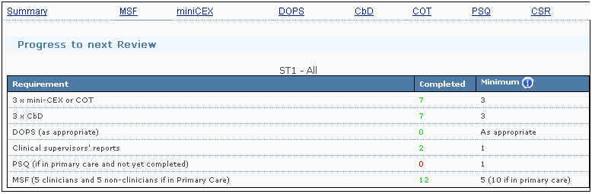
In the example above the trainee has not completed a PSQ during a 6 month posting in GP. We would also comment on the lack of DOPS done in the first year, although of course this trainee can do these at any time in the three years.
NB: The ‘minimum’ numbers are set to those required for an ESR period only – they do not reset when you look at All Reviews in a year, so ignore these.
If the minimum requirement has not been achieved, then you must advise an outcome 5 (more later). If the deficit is a PSQ alone (as above) and they no longer have the chance to address this within 4 weeks then give an outcome 1 and record in the checklist the requirement to complete a PSQ in their next GP placement (ST2 or 3). This would be in addition to the one required in ST3.
LTFTTs: Those working less than full time are expected to do pro-rata WPBA. So a trainee working 50% of full time would take 2 years to do the annual requirement equivalent for a full time trainee. You should make this judgement on the total assessments done only on TRANSITION ARCPs. For CALENDAR ARCPs make a judgment whether the trainee is engaging and doing the right amount given their time commitment. (see p 3)
The numbers of assessments should have been entered into the checklist already, but sometimes trainees load more assessments after their ESR, so it’s best to check both the box form and the dated assessments, especially if they are short.
You can look at the individual assessments by clicking on the blue links in the top line of the chart. Again it is a good idea to check one or two to make sure they have been assessed by a senior clinician.
You should then look at any CSRs and make a comment on whether there are any concerns raised by feedback or comments within them. There is a box for this on the checklist, and a table with word pictures in the document above for assessing the quality of the CSR itself.
- Educators Notes
Read any notes here – this is the place you are most likely to find any concerns, and what has been said and done about them. You can note any comments in the box marked ‘Professional Conversations and Educators Notes – cause for concern?’
- PDP
Click on the blue link in the left hand menu (see above).
Here, you are looking at whether the trainee is using the PDP regularly, updating it, and adding appropriate learning objectives – some from their learning logs.
Those objectives which have yet to be achieved are marked with a red cross. Check to see if there are any out of date ones. And also whether the PDP is up to date.
Then look at the objectives themselves and assess whether they are Specific, Measurable, Achievable, Relevant and Time limited. Make a comment about this on the checklist, and also whether the PDP is active or not.
It is suggested that an ‘Active’ PDP should incorporate the learning objectives agreed with the ES, and that there should be at least one active entry in the six months prior to an ESR/ panel.
Make any comment about the PDP on the checklist. If their PDP is inactive, make a recommendation on the checklist. This alone would not determine an outcome 5.

- Learning Log
Now click on Learning Log in the left hand menu.
You need to assess the quality of the log – in terms of number, breadth, and depth. The guidance of 2 - 3 entries a week would result in about 100 entries per year.
You can set the logs per page to 10 or 25 –it’s easy to work out how many logs there are in total (for all years to date). However, using 10 gives a more accurate idea, as the last page is the one which has fewer if there is not a multiple of 10 or 25 (in this example page 10).
(The pages number in the checklist is done with the setting to 10)


Have a quick look at the links within the log – curriculum headings can be added by trainee and trainer, whereas competence links can only be added by the trainer. The links should be supported by evidence within the log entry. Tip: you can sometimes get a feeling for over or under linkage after looking at the curriculum coverage page.
If linkage is poor (too much or too little) then you can make a comment on the checklist, to help the panel give feedback. Advice from the college is that ‘most entries will translate into a relatively small number of curriculum linkages’
Here are a couple of examples:
You should also specifically look at the following log pages:
Significant Events: They should be entering some every year – there is no minimum, but these are a good way of demonstrating quality improvement under competence 10 (Maintaining performance). You might want to make a comment about absence of these on the checklist. The competency word picture is here:
Engages in significant event reviews and learns from them as a team-based exercise.
Audit: Again at ST3 we would like to see a full cycle audit, or at the very least evidence that they understand the process and theory of clinical audit. This once again demonstrates under competence 10 (appx B). Some projects fit the bill too – depending on quality. The competency word picture is here:
Participates in audit where appropriate and uses audit activity to evaluate and suggest improvements in personal and practice performance (competent). By involving the team and the locality, encourages and facilitates wider participation and application of clinical governance activities (excellent).
Out of Hours (OOH): Because this area meets two requirements – that of achieving competence, and of the contractual obligation to do the equivalent of 6 hours per month in GP – we usually add up the hours to make sure that the trainee has done enough. Trainees should have completed 108 hours if they have undertaken 18 months of GP training. Note that because this is a contractual requirement it must be met at all stages including extensions Less than full time (LTFT) trainees can work pro rata and in innovative posts only the time actually in general practice is included. We are advising trainees to write the session duration in the title, and if possible the running total. We are also encouraging trainees to upload log sheets from OOH, but it is time-consuming to open all these - however sometimes you have to in order to assess the hours worked. Don’t forget that the more time someone spends in GP the more OOH they should do.
If you are unable to assess the hours worked then ask for advice.
Reflection: There are word pictures about the quality of the learning log entries (in the document embedded above and also at the bottom of the checklist). You need to rate the quality of the log entries and enter a judgment and formative feedback on the checklist.
Tip: Useful way of judging – since most of the reflective content is at the bottom of the form, highly reflective entries usually look like Christmas trees,  whereas journalistic ones look more like Apple trees.
Examples:
11 Progress to Certification
This is the last bit. Click on the heading on the left hand menu. This section is especially important for final ST3 trainees, but gives some useful information on other trainees too. It also provides access to reviews and previous ARCP reports.
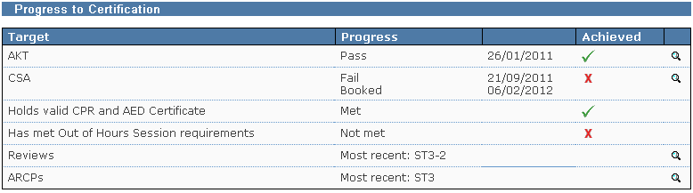
By clicking on the magnifying glasses on the right hand side you can examine scores for AKT and CSA and look at feedback after passes and fails for the CSA.
NB: the OOH should be signed off for the final ESR for ST3s.
CPR and AED certificates should be uploaded, but often are not. If not you could make a comment on the checklist, but there are no sanctions. We trust the educational supervisors to check before ticking these boxes.
Needless to say at final ST3 all areas here should be ticked.

That should be the end – all you have to do now is to decide whether this trainee’s progress is satisfactory or not, and to choose the ARCP outcome. Please enter this in the checklist at the end of the table, and put your reasons in the Other Notes box above, especially if you give an unsatisfactory outcome (2,3, or 5). Ignore the U Numbers and N Numbers – the panel will complete those.

Special Cases:
Academic Trainees
Trainees on an academic programme will need to complete both the full training programme and meet the requirements of the academic programme. They must have an academic educational supervisor who will normally be different from their clinical educational supervisor. This academic ES is responsible for drawing up an academic training programme with the trainee, with clear milestones for delivery. Both supervisors should be aware of the trainee’s overall clinical and academic requirements.
The trainee will meet regularly with both educational supervisors, and an annual assessment of academic progress should take place ideally one month before the joint academic/clinical ARCP panel. The academic supervisor completes the Report on Academic Progress form which once agreed with the trainee is submitted to the panel.
When choosing an outcome 6 for an Academic ST4, you must choose the outcome marked ‘(academic)’.
Commissioning Fellows (ST4s)
These trainees are assessed in a similar way to Academic Trainees by a combination of clinical/ commissioning supervisors and panel.

Thank you for volunteering, and we hope you enjoy the day and will learn from it. Please feel free to give us feedback, both on this guide and on the screening process.

APPENDIX A

WORD PICTURES FOR ASSESSING QUALITY IN EPORTFOLIO

Chart 1 | ES Ratings
Needs Further Development | Acceptable (A) |  | Excellent (E)
Needs Further Development |  |  | (in addition to A)
a) The basis for judgements is not clear, i.e. they are not referenced to the evidence. They are not linked to evidence or there is a substantial lack of evidence to support the judgments made by the Educational Supervisor | A) Judgements are generally referenced to a spread of the available evidence |  | Judgements show sophistication, synthesising evidence from a number of sources.
b) Where the judgements can be evaluated, they do not appear to be justifiable. Where evidence has been cited for any judgments, the accuracy or robustness of the linked evidence is questionable. | B) Judgements appear to be justifiable |  | Suggestions for trainee development clarify the learning outcomes to be achieved.
c) Suggestions for trainee development are inadequate in number and/or quality. Constructive suggestions for how the candidate might progress are lacking. | C) Suggestions for trainee development are routinely made and appear to be appropriate |  | The supervisor comments on the quality and range of the evidence-set in order to improve trainee insight and future data.
Chart 2 | Trainee log entries
Not Acceptable | Acceptable |  | Excellent (in addition to acceptable)
Information Provided  Entirely descriptive: e.g. lists of learning events/ certificates of attendance with no evidence of reflection | Limited use of other sources of information to put the event into context |  | Uses a range of sources to clarity thoughts and feelings. Demonstrates well developed analysis and critical thinking e.g. using the evidence base to justify or change behaviour
Critical Analysis  No evidence of analysis: i.e. an attempt to make sense of thoughts, perceptions and emotions. | Some evidence of critical thinking and analysis, describing own thought processes |  | Shows insight, seeing performance in relation to what might be expected of doctors
Self Awareness  No self awareness | Some self awareness, demonstrating openness and honesty about performance and some consideration of feelings generated |  | Consideration of the thoughts and feelings of others as well as him/herself
Evidence of Learning  No evidence of learning: i.e. clarification of what needs to be learned and why | Some evidence of learning, appropriately describing what needs to be learned, why and how |  | Good evidence of learning, with critical assessment, prioritisation and planning of learning

A log entry should ideally show:
- Some evidence of critical thinking and analysis, describing own thought processes
- Some self awareness demonstrating openness and honesty about performance and some consideration of feelings generated
- Some evidence of learning, appropriately describing what needs to be learned, why and how
- Appropriate linkage to the curriculum
- Demonstration of behaviour that allows linkage to one or more competency areas

CHART 3 – CSR
CSR Acceptable | CSR Needs Further Information
- Free text comments are specific and constructive | c) there is little or no formative feedback to the learner
- Where underperformance is noted or concerns are highlighted, free text comment is made and evidence cited | d) where grades are ‘borderline’ or ‘below expectation’, insufficient free text comment is made and little or no detail about concerns is provided

APPENDIX B

APPENDIX C

The MRCGP Blueprint
 |  | Coverage by licensing assessments
Curriculum |  | WPBA | CSA | AKT
Primary care management
Person-centred care
Specific Problem-solving skills
Comprehensive approach
Community orientation
Holistic approach
Contextual Aspects
Attitudinal Aspects
Scientific Aspects

APPENDIX D

ARCP TASK LIST (for reference)

- Last ARCP report

- Quick check of posts – specialties, duration

- Trainee self-ratings

- Educational supervisor ratings

- Curriculum coverage

- Skills Log (DOPS)
- Naturally occurring evidence
- Evidence: assessments
- PDP

- Learning Log
  - Quality and links
  - Significant events
  - Audit
  - OOH

- Progress to Certification

- Choose outcome and add any comments to form

Senior Clinician includes consultants, nurse specialists, nurse practitioners, SpR, and ST4 appropriate to the specialty, who has been trained to assess.
Appendix B

